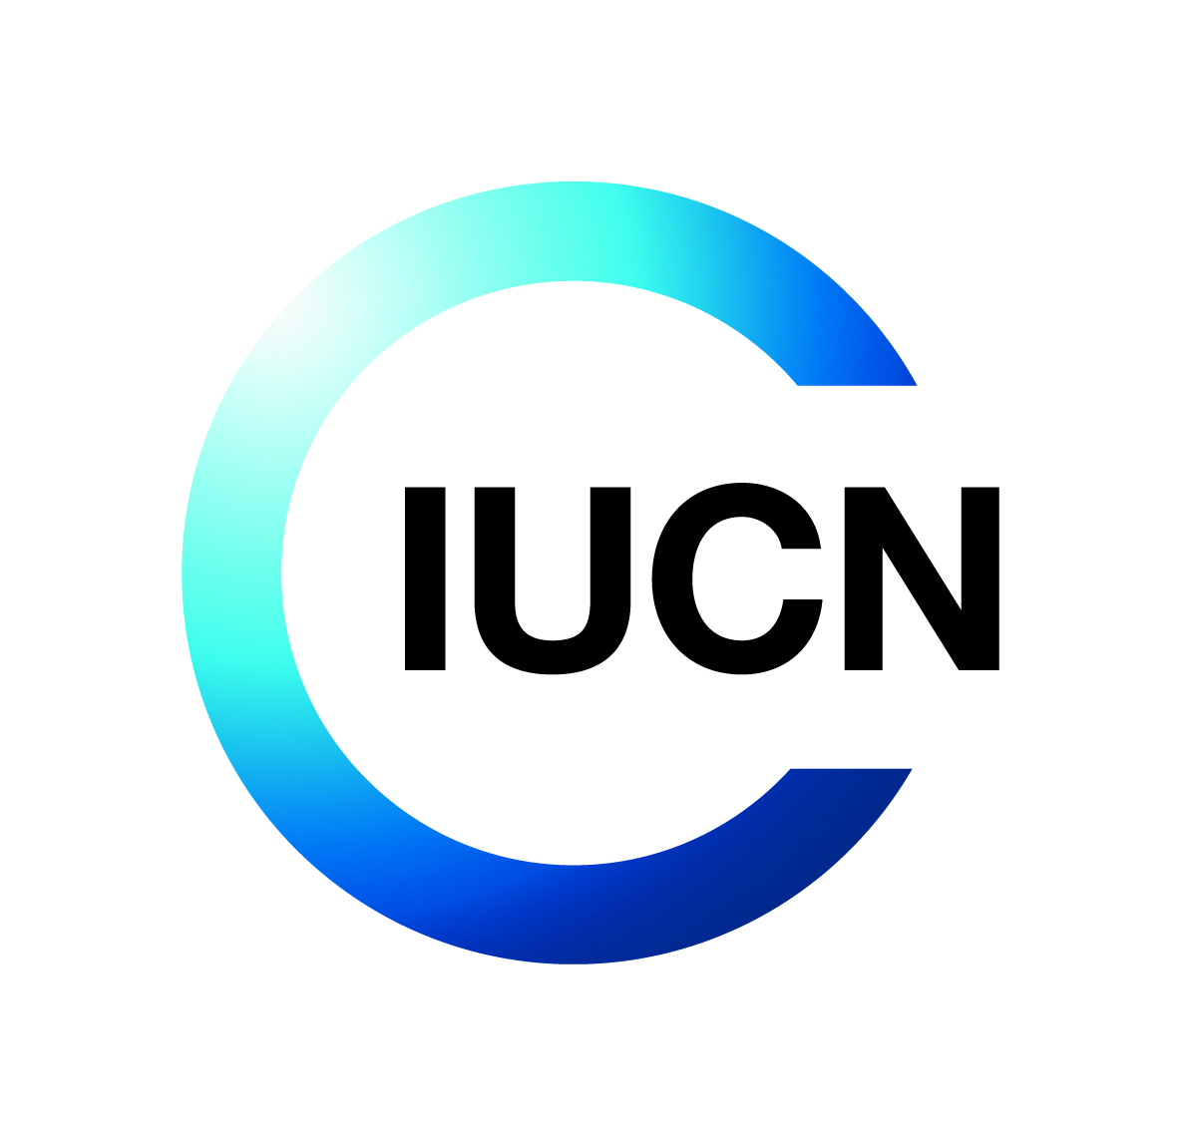

Terms of Reference (ToR)

**Title: Recruitment of a Consultant to Develop a DFMP Simplified Guide and Facilitate Capacity Building for District and National Stakeholders Under AREECA Programme**

**Objective of the Consultancy**

This consultancy has the following objective(s):

1. Offer an in-person training to district forest officers as well as key officers at Rwanda Forestry Authority and Ministry of Environment,
2. Develop a simplified guide in developing a typical DFMP and
3. Prepare report briefs for Nyagatare and Kayonza as standard briefs to be replicated for other DFMPs in the country.

**Background**

Project Reference: **P02954**

Donor reference: **DN00292**

**About IUCN**

IUCN is a membership Union uniquely composed of both government and civil society organisations. It provides public, private and non-governmental organisations with the knowledge and tools that enable human progress, economic development and nature conservation to take place together.

Created in 1948, IUCN is now the world’s largest and most diverse environmental network, harnessing the knowledge, resources and reach of more than 1,400 Member organisations and around 15,000 experts. It is a leading provider of conservation data, assessments and analysis. Its broad membership enables IUCN to fill the role of incubator and trusted repository of best practices, tools and international standards.

IUCN provides a neutral space in which diverse stakeholders including governments, NGOs, scientists, businesses, local communities, indigenous peoples organisations and others can work together to forge and implement solutions to environmental challenges and achieve sustainable development.

Working with many partners and supporters, IUCN implements a large and diverse portfolio of conservation projects worldwide. Combining the latest science with the traditional knowledge of local communities, these projects work to reverse habitat loss, restore ecosystems and improve people’s well-being.

[www.iucn.org](http://www.iucn.org)

<https://twitter.com/IUCN/>

**About the Project**

The Government through a consortium made up of Rwanda Forestry Authority (RFA), the International Union for Conservation of Nature ( IUCN), the Food and Agricultural Organization (FAO), Germany Development Agency (GIZ), World Resources Institute (WRI), the World Bank (WB), and the African Union Development Agency-NEPAD (AUDA-NEPAD) is undertaking a 5 years’ (2021-2025) Forest Landscape Restoration (FLR), Alliance for Restoration of Ecosystems in Africa (AREECA) Project.

The project is funded by the Federal Ministry of the Environment, Nature Conservation, and Nuclear Safety (BMU), and operates in diverse ecosystems in Rwanda, Kenya, Malawi, and Cameroon, aiming to boost the economic, ecological, and climate benefits of large-scale Forest Landscape Restoration (FLR) by restoring 100,000 hectares of degraded lands using viable land use options and enabling restoration efforts beyond the target landscapes and countries.

In Rwanda, AREECA is working to restore 25,000 ha of degraded lands by initiating viable land-use options on 5,000 ha in Kirehe and Nyagatare Districts and establishing various enablers to catalyse restoration—a move that is expected to have a fivefold radiative effect in East Province and beyond.

**Description of the Assignment**

1. Develop a simplified guide on DFMP preparation and a summary report brief on the recently completed Kayonza and Nyagatare DFMPs.
2. Deliver in-person training to District Forest Officers, officials from the Rwanda Forestry Authority (RFA) and Ministry of Environment, and key conservation NGOs on how to use the DFMP development and application tools for improved forest management.

**Detailed objectives and Scope of Work**

1. **Work package 1: Technical Documentation**

* Review the full DFMPs for Nyagatare and Kayonza Districts.
* Develop a Simplified DFMP Preparation Guide, including:
* Overview of DFMPs and their role in sustainable forest management
* Step-by-step process for DFMP development using FMES
* Instructions on defining Forest Management Units (FMUs)
* Guidance on revising management prescriptions and integrating local data
* Illustrative visuals, case examples, and tips for practitioners
* Produce a 8 to 10-page summary brief that synthesizes contextual information, key findings, priorities, and lessons learned from Kayonza and Nyagatare DFMPs.

1. **Work Package 2: Training Design and Delivery**

* *Design 5-day training programme targeting ~ 60 participants from*:
* Districts
* RFA & Ministry of Environment
* Forestry sector NGOs, conservation partners & AREECA consortium members.
* *Develop training content that includes*:
* FMES overview and tools
* Forest inventory data interpretation
* FMU creation, scenario planning, and adaptive management
* Practical sessions and guided exercises
* *Facilitate two field-based experiential learning sessions.*
* *Collaborate closely with RFA technical teams and ensure contextual relevance.*
* *Prepare and submit the training Report*

**Duration of the Assignment**

From October 01 2025, to November 15,2025.

**Deliverables and Activities**

The consultant will provide the following deliverables and carry out the following activities:

|  |  |  |
| --- | --- | --- |
| **Deliverable** | **Description** | **Timeline** |
| Inception Report | Detailed methodology, annotated outline of guide, draft training plan | 1 week |
| Simplified S/DFMP Guide | Illustrated, user-friendly guide in English (PDF & print-ready) | 4 weeks |
| DFMP Summary Brief | Concise/brief analytical report (8-10 pages) for Kayonza and Nyagatare DFMPs reports | 4 weeks |
| Training Materials | Power Point, slides, manual, practical exercises, and DFMP development tools guidance packs | 1 week before training |
| Delivery of Training Workshop | Facilitation of 5-day workshop including field sessions | 1 week (dates TBD in consultation with IUCN) |
| Final Report | Post-training report, briefs and guides with training evaluations and recommendations | 1 week after training |

**Payment Schedule**

The Timetable below summarises the chronological order of deliverables and indicates milestones at which IUCN will pay the Consultant.

|  |  |
| --- | --- |
| **Deliverable** | **Milestone payment** |
| Inception Report | 30% |
| Development of Training materials and Training Delivery | 40% |
| Final Report submission and Approval | 30% |

**Skills and Experience**

The consultant must have the following skills, education and experience as a minimum:

* Advanced university degree (Master or Higher) in Forestry, Natural Resource Management, GIS, or related discipline
* Minimum 10 years of experience in leading sustainable forest management and forest planning in Rwanda.
* Demonstrated practical experience in developing DFMPS and use of FMES and other forest management planning tools/software in the development of Sustainable Forest Management Plans.
* Experience in capacity-building in forest management and planning.
* Prior work and legal right to work in Rwanda.
* Excellent English proficiency: knowledge of Kinyarwanda is a must.

**Supervision and coordination**

The consultant will report to and work under the supervision of the Project Regional Coordinator (Regional Geospatial information and ROAM Officer) and in Country project Manager (GIS and Knowledge Management Officer).