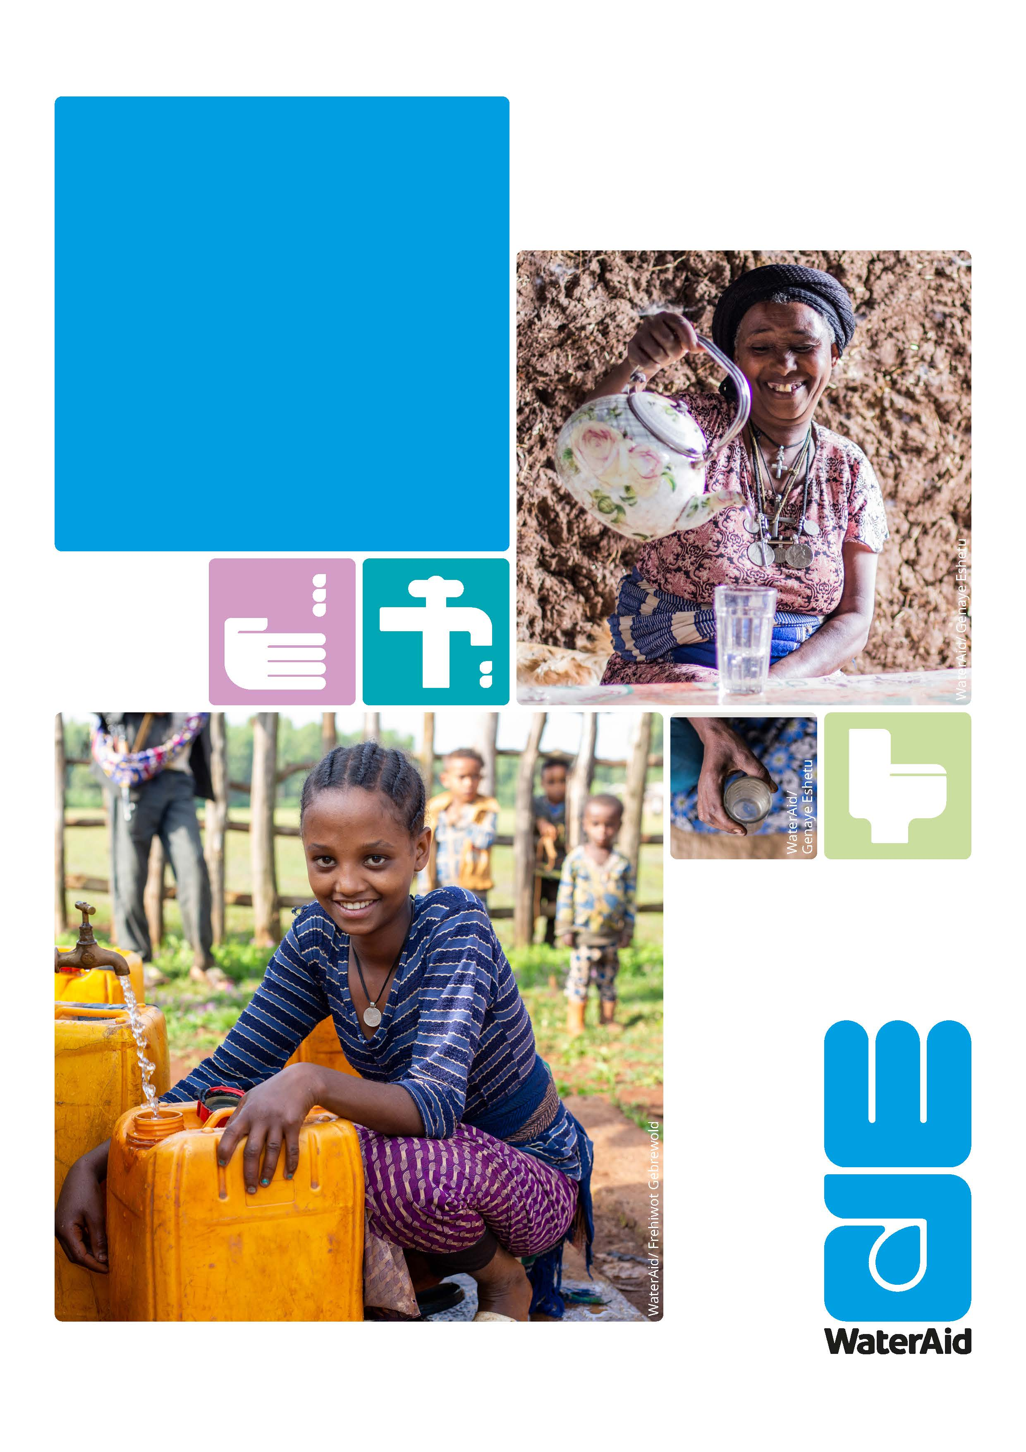
Job Description for Head of Finance & ICT

INTRODUCTION
WaterAid’s Vision is of a world where everyone has access to safe water and sanitation. Our mission is to transform lives by improving access to safe water, hygiene and sanitation in the world’s poorest communities, WaterAid works with partners to maximize its impacts for policy change/influence.

WaterAid Rwanda (WARw) works through supporting local organizations and government to plan and implement inclusive and sustainable services of water, sanitation and hygiene (WASH). WARw also seeks to influence the policy change through government and other key WASH stakeholders to secure and protect the right of poor people to safe, affordable water and sanitation services. Occupying the position of Head of Finance and ICT in WaterAid is an exciting opportunity to work with WaterAid and contribute to the achievement of the national and global goals towards realizing the WASH access for everyone everywhere.

WaterAid is fully committed to protecting those with whom it comes into contact. WaterAid is committed to ensuring that wherever we work in the world there is no tolerance for the abuse of power, privilege or trust. WaterAid reinforces a culture of zero tolerance towards any form of inappropriate behavior, abuse, harassment, or exploitation of any kind. The safeguarding of our beneficiaries, staff, volunteers and anyone working on our behalf, is our top priority, and we take our responsibilities extremely seriously. All staff and volunteers are required to share in this commitment through our Global Code of Conduct. We will conduct the most appropriate pre-employment references and checks to ensure high standards are maintained.

For more information about safeguarding at WaterAid, please visit our safeguarding webpage at: https://www.wateraid.org/uk/safeguarding-at-wateraid




- About the role

Job Title | Head of Finance & ICT
Place of work: | WaterAid Rwanda Head Office, Kigali, Rwanda
Grade: | G1
Contract type: | Fixed term (3 years renewable)
Reports to: | Country Director
Manages: | Management Accountant, Finance Specialist, ICT4D Officer
Work Relationships | Internal: Head Policy, Advocacy and Cooperation; Head of Programs, Head of Business Development, PMEAL Manager, Head of POD, Programme staff, WaterAid East Africa Regional team, UK Finance and other WaterAid Federation Member offices.  External: Donors, Consortia partners, implementing partners, relevant government ministries, other institutions, service providers.
Budget Responsibility | Oversee overall CP budget management and management or Finance department budget.
- Job Purpose

Job Purpose | The Head of Finance & ICT role provides Strategic and proffesional leadership and is resposible for all finance functions as well as ICT for Development (ICT4D) within the country programme. The role is responsible for developing and maintaining all necessary financial controls, systems and processes to ensure the efficient and effective management of the organization’s finances and compliance with WaterAid’s Financial Management Framework, statutory requirements, regulations, procedures and donors requirements. The role is accountable for planning, development, and review of WARw financial policies procedures and systems, strategies and budgeting, prudent management, and control of financial resources.  It supports the capacity building of WaterAid partner organisations to undertake finance activities that resonate to WaterAid and donor requirements. The role manages ICT4D function and works collaboratively with other members of SMT in resource mobilization, partner engagement, contract management, grant management and donor compliance by ensuring high quality and timely grant reports to demonstrate WaterAid’s added value to donors and partners.

- Main Responsibilities and Duties

Strategic Management
- Contribute to strategic leadership of the Country Programme as part of Senior Management Team (SMT) and implementation of the country programme strategy.
- Provide strategic and efficient financial management for the CP.
- Develop and maintain appropriate and effective financial strategies, plans and policies to support the strategic plan.
- Lead the financial forecasting process to produce relevant, accurate and timely financial forecasts across WaterAid.
- Develop and maintain effective working relationships with other SMT members to understand their financial support requirements, co-ordinate appropriate responses and ensure implementation of finance policies and support to the SMT members in preparation of plans and budgets.
- Maintain oversight of the country programme funding position and grant management.
Financial Management, and Reporting
- Ensure all financial accounting processes are completed; the Income and Expenditure accounts & balance sheet are reviewed and reconciled as appropriate and monthly returns are submitted within corporate deadline.
- Lead on the provision of monthly management accounts, reporting financial performance and explaining reasons for deviations/ variances from plans and proposing major actions required to address any major deviations.
- Ensure the timely submission of high-quality financial reports, for internal and external audiences. Proactively draw attention on any problem areas initiate solutions in consultation with the Country Director and other staff as appropriate. Actively support and review the development of financial plans/ development for funding proposals and budget planning for concept notes, the donor report preparation and funding matrix updates.
- Support, review, and monitor expenditure against grant agreements, working with the SMT to resolve issues as necessary.
Grants Management:
- Support the completion of new and potential partner capacity assessments, making recommendations on whether to engage in a partnership arrangement with such partners as well as identifying risk management plans, partner financial management capacity needs and plans where required.
- Ensure regular review of partner reports are completed and funds transferred for project activities are properly accounted for and utilized for designated activities.
- Ensure high quality partner monitoring visits with programme staff are conducted on a regular basis and that financial assessment reports are produced on a timely basis.
- Ensure all existing and potential donor income is accurately incorporated into WARw internal planning process, and plans are in line with donor requirements and WaterAid policy and practice.
- Work with Programmes and Finance to review progress during WaterAid ‘s internal review processes including variance analysis of grant outputs and expenditure.
- Financial administration and reporting including preparation and submission of grant reports, development and adjustment of associated budgets, coordination of budgeted funds, screening requests for expenditures.
- Ensure appropriate donor management systems, records and processes are in place, up-to-date and in compliance with WaterAid policy and practice.
- Monitor and coordinate compliance with donor requirements, including grant reporting.
- Work collaboratively with internal teams and implementing partners to ensure all contractual funding requirements are met and utilization of funds does not exceed the budget.
- Liaise with Programme staff and the donor to ensure high quality visits.
- Highlighting key risks related to grant-funded projects, such as under/over- spends, delayed delivery of commitments, capacity gaps, and donor relationships.
- Work with internal teams and partners to identify capacity needs and build capacity in areas such as report writing and documentation.
Financial Risk Management
- Develop, implement, and maintain financial management procedures, risk assessments and control measures to manage, monitor and audit transactions across the Country Programme and to ensure compliance with WaterAid’s overall policies, good practice standards, external donor requirements and national laws and regulations, identifying corrective measures as required.
- Support capacity building of WAU staff and partner organizations in areas of financial management and reporting.
- Develop and implement procedures for assessing the value for money that WaterAid obtains in all its activities to identify cost savings and ensure financial efficiency and value for money principles are an integral part of the Country Programme activities.
Audit, Compliance and Legislation
- Support on the internal and external audits and coordinate the development and implementation of action plans with SMT to address external and internal audit recommendations by providing timely management response to all mandatory stakeholders.
- Maintain up to date knowledge of financial legislation, donor reporting requirements and good practice to ensure that the Country Programme complies with all legal requirements and proactively stays at the at the forefront of financial management practice.
- Ensure that the organizations’ statutory and management reporting mechanisms are efficient and timely. Produce consolidated CP accounts; statutory year end accounts are produced and submitted to the various institutions.
- Facilitate and co-ordinate both internal and external audits and lead the development and implementation of action plans based on audit recommendations, monitoring progress on achievements.
- Ensure relevant reconciliation, accurate financial reports and timely audits in accordance with WaterAid and donor requirements.
Team management
- Lead the Finance Team and ICT4D Officer, ensuring an effective utilization of their capacity toward the achievement of the unit objectives.
- Ensure effective performance management of the Finance Team and ICT4D Officer
Safeguarding, Safety & Security
- Create and maintain an environment which upholds WaterAid’s Global Code of Conduct and associated safeguarding and child protection policies.
- Ensure that Safeguarding, Child Protection, and Gender Equality policies are fully embedded in project design and implementation as well as relationships with all actors.
- Ensure that comprehensive health, safety and security measures (e.g. risk management plans, local security protocols) have been put in place when designing Programmes / project and are consistently upheld during their implementation.
- Ensure that partners WaterAid works with are adopt the same health, safety and security standards (as defined in any applicable WaterAid health, safety and security policies), and arrange for capacity building support where gaps or weaknesses are identified.
- Understand and put into practice the responsibilities under Safeguarding, Child Protection and Gender policies and Code of Conduct (CoC).
- Adhere to any local security protocols that have been put in place when working in the office, travelling to the field, or undertaking project / Programme activities.
- Immediately reports any health, safety and security incidents or near-misses that occur on WaterAid duty to their line manager, Security Focal Point or CD.
- Behave and act in a manner that does not put colleagues or anyone that interacts with WaterAid in immediate danger or harm’s way.
Other roles
Perform any other related responsibilities, tasks or activities as reasonably required by line manager as the range of duties are not intended to be a complete description of all.

- Key Competences, Skills, experience, and Knowledge

Qualifications, Knowledge, Skills, and Experience

Essential
- A master’s degree in finance, Accounting, or Business Studies. Relevant Bachelors degree and commensurate practical experience, and /or pursuing masters studies may be considered.
- Fully completed accounting qualification/certification e.g. CA, ACCA, CIMA, CPA
- ACMA, CFA. Part professional qualifications or working towards certifications and having other experience may be considered.
- Minimum of ten (10) years’ experience in financial, accounting and grants management experience of which five (5) must be at senior management level, and preferably in International NGO. Relevant bachelor’s degree and commensurate practical experience, and /or pursuing master’s studies may be considered.
- Fully completed accounting qualification/certification e.g. CA, ACCA, CIMA, CPA
- ACMA, CFA.
- Member of the Rwanda Institute of Certified Public Accountants of Rwanda (ICPAR) or
or an equivalent body of professionals with added advantage.
- Able to plan, prioritize and organize self and others. Ability to work under pressure and meet deadlines.
- Excellent analytical skills with the ability to link financial results to programme and operational performance drivers to the organisation.
- Competency in WaterAid common approaches to work including partnerships, convening, inclusion, systems strengthening, creating behavioural change, and mainstreaming gender and inclusion of youth.
- Experience in preparing and monitoring budgets & developing monitoring and reporting systems.
- Ability to provide financial analysis and interpretation to Country Management Team for decision-making.
- Knowledge of government policies and regulations on financial management and taxation.
- Knowledge of international donor reporting requirements; demonstrable experience in strong donor and partner relations and the ability to build and maintain strong working relationships with donors.
- Risk analysis and risk management experience.

Desirable
- Strong knowledge of fund accounting regulations for non-profit organizations.
- Experience in working with an international NGO.
- Experience in using SUN systems and vision excel.
- Knowledge of water, sanitation, or hygiene projects.
- Basic understanding of Project Management.
Behavioral competencies

- Decisive with excellent judgement
- Demonstrated ability to lead a team, leadership qualities, team player and problem-solving skills.
- Possess the ability to think strategically with excellent planning and prioritization skills.
- Strong analytical/problem solving skills.
- Commitment and modeling WaterAid’s values, high personal integrity, and ethical behavior; flexible attitude, sense of transparency, proactive and has respect for gender, diversity and organizational culture.
- Result -oriented, agile, and adaptable to a changing environment
- Should be able to draw confidence and support from others.
- Excellent interpersonal skills – builds good relationships with internal and external stakeholders; team player with ability to work effectively in a diverse team environment, respect for gender, diversity, and organizational culture
- Ability to manage a complex and demanding workload; highly self-motivation, able to work without close supervision.

