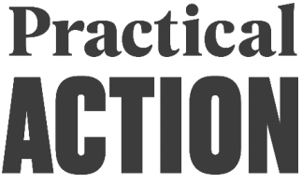
JOB PROFILE
BUSINESS DEVELOPMENT & PARTNERSHIPS COORDINATOR

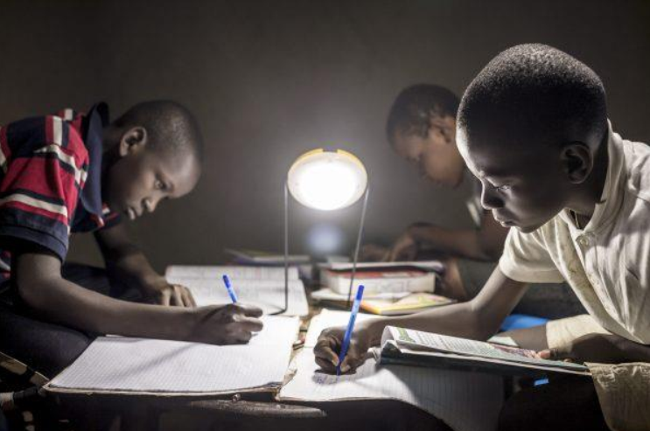

Practical Action
ABOUT US
We are an International Development Organization putting ingenious ideas to work so people in poverty can change their world. We help people find solutions to some of the world’s toughest problems. Challenges made worse by catastrophic climate change and persistent gender inequality. We work with communities to develop ingenious, lasting and locally owned solutions for agriculture, water and waste management, climate resilience and clean energy. And we share what works with others, so answers that start small can grow big.
We are a global change-making group. The group consists of a UK registered charity with community projects in Africa, Asia and Latin America, an independent development publishing company and a technical consulting service. We combine these specialisms to multiply our impact and help shape a world that works better for everyone.
OUR AIMS
We help people find solutions to some of the world’s toughest problems, made worse by
catastrophic climate change and persistent gender inequality. Our aims are to:
- Make agriculture work better for smallholder farmers, many of them women, so they can adapt to climate change and achieve a good standard of living
- Help more people harness the transformational effects of clean affordable energy and reduce avoidable deaths caused by smoke from indoor stoves and fires.
- Make cities in poorer countries cleaner, healthier places to live and work.
- Build disaster resilience into the lives of people threatened by hazards, reducing the risk of hazards and minimizing their impact on lives and livelihoods.
PRACTICAL ACTION RWANDA
In Rwanda, we are recognized leaders in clean cooking and sustainable energy solutions. This includes ground-breaking work in solar, wind and water powered electricity generation, often delivered through independent mini-grids. We bring rural communities, people in refugee camps, energy providers and decision makers together to put sustainable, clean energy solutions to work for the people who need them most.
In our strategic business plan 2021-2025, we propose to extend our current reach and scope in Rwanda by deepening our energy work and stretching our portfolio to work with small holder farmers to make agriculture work better for them.
Practical Action
ABOUT THE ROLE
ROLE PURPOSE
The Business Development & Partnership Coordinator is responsible for driving the Country Program’s resource mobilization efforts, ensuring long-term financial sustainability and growth in line with Practical Action's global strategy and the Rwanda Country Strategic Plan. The role requires a strategic, proactive, and ethical approach to identifying, cultivating, and securing large-scale, multi-year funding from institutional, corporate, and private sector partners. This role serves as the central connection between technical program delivery, strategic communication, and ethical resource mobilization, ensuring all partnerships adhere to global non-profit standards of integrity and transparency.
SCOPE OF THE ROLE
Title | Business Development & Partnership Coordinator
Reporting to | Head of Programs
Unit | Business Development team
Direct reports | Communication Officer
Location | Rwanda
Grade | 6
ACCOUNTABILITIES
Strategic Business Development and Long-Term Resource Mobilization (60%):
- Lead the development, execution, and monitoring of the Country Office’s Business Development Strategy and Income Generation Plan, explicitly targeting multi-year funding (3-5 years) and diversifying the portfolio to include institutional donors large foundations, and private sector partners.
- Systematically research, track, and cultivate relationships with prospective high value donors and partners. Manage a rolling pipeline of opportunities, working closely with Technical Leads to co-design transformative, scalable program concepts that align with donor priorities (e.g., climate resilience, sustainable energy, gender equality, Regenerative Agriculture, Waste Management).
- Facilitate a 'co-creation' approach with strategic partners, including local NGOs and Community-Based Organizations (CBOs), to ensure proposals are locally led, contextually relevant, and meet the localization agendas of major global donors.
- Lead and coordinate complex proposal development processes, managing cross functional teams (Programs, Finance, M&E, P&C) to produce high quality, compelling, and compliant bids, ensuring timely submission and adherence to all donor guidelines (including budgetary transparency and accountability).

Strategic Partnership Management and Compliance (25%)
- Act as the primary focal point for key donors and strategic partners in Rwanda. Establish and maintain deep, trusted relationships built on open dialogue, mutual accountability, and shared vision, transitioning relationships from transactional funding to strategic collaboration.
- Oversee partner pre-award due diligence, risk mapping, and safeguarding assurance for all potential collaborations, ensuring compliance with Practical Action's internal policies and international standards (e.g., PSEA [Protection from Sexual Exploitation and Abuse], Anti-Fraud, and Anti-Corruption).
Strategic Communications and Visibility (15%)
- Develop and disseminate key country level messages, working with Communication Officer, the Country Director and Global Communications Team to position Practical Action Rwanda as a leader in its thematic areas. This includes developing high impact briefing notes, policy papers, and capability statements targeted at specific donors and policymakers.
- Proactively identify, gather, and package compelling stories, case studies, and visual content that clearly demonstrate the impact and sustainability of Practical Action's interventions, tailoring these narratives to secure specific donor interest and drive follow-on funding.
- Ensure the Country Office’s digital presence (website content, social media) is professional, up-to-date, and reflects a consistent brand identity. Oversee the development of the annual report/summary for key stakeholders, highlighting programmatic achievements and financial stewardship.

Knowledge, learning and impact
- Ensuring that all internal reports, Donors’ meeting minutes, work plans and other collective work documents are stored in an accessible and updated way on SharePoint.
- Contribute to Practical Action’s Knowledge Team (within Policy and Practice) work
- Share experiences and lessons from implementing Practical Action knowledge and communication processes and systems;
- Participate in regular ‘Knowledge Buster’ meetings with other knowledge colleagues in Head Office.
- Coordinate with Country office to create impact awareness
Candidate Profile
To be successful in the role, the ideal candidate will be able to demonstrate the following
experience, knowledge and skills:
Qualifications
- A minimum of a bachelor’s degree in international development, Communications, Business Administration, or a related field. A master’s degree is preferred.
- Fluency in English (written and spoken) is essential. Proficiency in Kinyarwanda and/or French is a significant advantage.
Experience
- Minimum of three (3) years of progressive experience in Business Development, resource mobilization, or external relations within the international non-profit or development sector.
- Proven track record of securing high-value, multi-year funding (>$500k) from institutional donors such as USAID, FCDO, EU, or large foundations.
- Demonstrable experience leading complex proposal development processes, including proposal writing, budget development, and partnership structuring.
- Proven ability to research, analyze, and communicate donor trends and priorities in the Rwandan and regional context.
- Experience in leveraging strategic communication to achieve funding or policy objectives.
Core Competence
- Ability to analyze donor landscapes, funding trends, and propose practical, long-term funding solutions.
- Exceptional interpersonal and negotiation skills to build trust and lasting partnerships with senior external stakeholders (donors, government, private sector).
- Superb writing, editing, and verbal communication skills, with a proven ability to translate complex technical information into accessible, persuasive narratives.
- Deep understanding of NGO compliance requirements, safeguarding, and anti-fraud protocols.
- Commitment to promoting gender equity, social inclusion, and local ownership in all funding and partnership efforts.
- Experience of working in a complex multicultural environment
- Excellent administration and organization skills, including digital filing (essential). Knowledge of SharePoint would be an advantage

Desirable
- Degree in relevant field, or equivalent work experience
- Good understanding of search engine optimization;
- Understanding of how to plan, implement and monitor communication strategies
Behaviors & Motivations
The most important behaviors for role to be successful:
- Connects and collaborates
- An excellent collaborator that is accessible, reliable and trusted to add value to
others work.
- Proactively able to create momentum and opportunities to connect
- Continually learns
- A source of expertise and knowledge for others in communications and knowledge
- Treats difficult scenarios as learning opportunities
- Is creative
- A questioning attitude: actively interested in what’s going on & always looking for
better ways of doing things
- Able to analyze and understand information quickly, apply insights and knowledge in
a structured way and propose practical solutions
- Inspires
- Is able to understand needs in a given situation, applies and explains sound
judgement and analysis whilst demonstrating behavioral integrity
- Gets the job done
- Accepts responsibility and has the drive to follow through on agreed objectives;
plans,
- Prioritizes, and monitors own performance for delivery
- Adaptable and able to follow instruction when requested

KEY BENEFITS
Inspiring people is central to Practical Action’s mission. This starts with our own staff. Through talented and committed staff we will effectively deliver practical answers to our beneficiaries and influence others to build on our philosophy to deliver practical answers to poverty. The role holder should therefore expect a competitive remuneration package complete with other non-financial benefits that is at par with international standards.

Personal qualities
- Self-Motivation: Taking responsibility to ensure commitments are met and achieve objectives despite problems and frustrations.
- A good team player
- Creative and proactive.
- Able to work effectively in a diverse team environment
- Good motivator of self and others
- Willing to work additional hours at crucial times
- Willing to travel at short notice nationally and internationally.
- Personal integrity.
- Commitment to Practical Action’s working culture (inspiring, dynamism, connectedness, learning, creativity, getting the job done)
- Outcome focused.

HOW TO APPLY
A detailed Job Profile can be accessed from Practical Action website
If you believe that you are the right candidate for the role and have the experience, skills and the ability we are looking for, please submit your application (a cover letter and updated CV) to this email: recruitment.rwanda@practicalaction.org
Clearly indicate in the subject line the position you are applying for.
The application deadline is November 5th, 2025. However, the shortlisting process will be done on the rolling basis until we find the right potential candidates for further selection steps.
We treat all applications for employment on their merits and do not take into consideration any factors that are not relevant to the job such as disability, race, age, religion, gender, gender reassignment or sexual orientation.
Practical Action is committed to safeguarding and protecting children and vulnerable adults and as such candidates will be subject to pre-employment checks.
Only shortlisted candidates will be contacted for further process.

