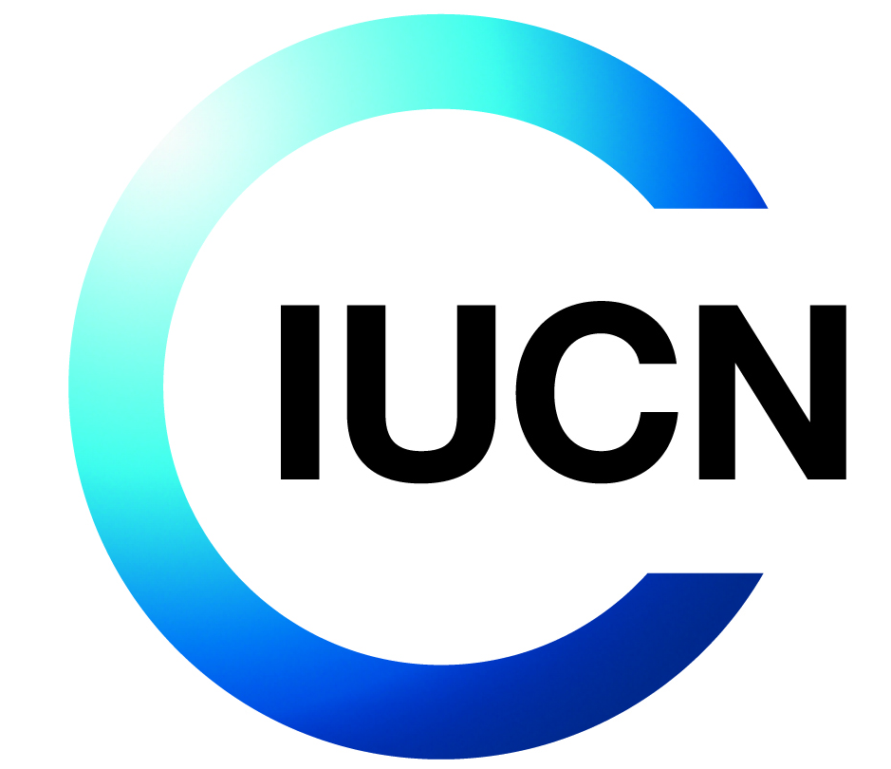
Terms of Reference for IUCN Consultancy

Title: Implementation of the gender and environmental and social management system (GESS) for the TREPA Project - Transforming Eastern Province of Rwanda through Adaptation.
Objective of the Consultancy
This consultancy has the following objective(s):
- Ensure that environmental and social risks of TREPA sub-projects/site-level activities are proactively identified, assessed, mitigated, and reported in accordance with IUCN’s Environmental and Social Management System (ESMS), the Green Climate Fund’s (GCF) Environmental and Social Safeguards policy (ESS), and national safeguard policies and legislative frameworks.
- Support the systematic application of the ESMS procedures which are established in the project’s Environmental and Social Management Framework (ESMF) throughout the project lifecycle.
- In case adjustments to the ESMF procedures are required (e.g. due to changing context, national policies etc.), ensure timely update and approval by GCF.
- Integrate risk management strategies into project implementation, supervision, monitoring, and reporting. This includes overseeing compliance with ESMS requirements, supporting the preparation and implementation of safeguard instruments for each sub-project (e.g., ESMPs, GRM, SEP, Gender Action Plan), and ensuring that these tools are effectively embedded in field operations.
- Deliver technical support, coaching, and training to enhance safeguard understanding and compliance across all actors involved in project implementation to ensure consistent and high-quality application of safeguard standards.

Background
Project Reference: P03168
Donor reference: FP167
The International Union of Conservation of Nature’s (IUCN) mission is “to influence, encourage and assist societies throughout the world to conserve the integrity and diversity of nature and to ensure that any use of natural resources is equitable and ecologically sustainable.” IUCN projects aim to achieve positive conservation and social outcomes, including benefits for communities that depend on natural resources.
However, unintended negative environmental and social impacts may occur when projects are implemented. Within the context of its mission, IUCN intends to ensure that appropriate measures are taken to avoid or minimise negative environmental and social impacts while stimulating positive impacts.
To put this intention into practice, IUCN has established an Environmental and Social Management System (ESMS) as an intrinsic part of IUCN’s project cycle. It provides systematic steps and operational tools for managing the environmental and social performance of projects implemented or supported by IUCN. The system allows IUCN to screen potential projects for negative environmental or social impacts and develop suitable measures to avoid, minimise, or compensate for these impacts. It also ensures that the implementation and effectiveness of mitigation measures are monitored and that any impacts arising during execution of the project are addressed.
The ESMS requirements are documented in the form of a management manual (referred to as the ESMS Manual) that, together with the ESMS Standards, establishes IUCN’s ESMS Policy Framework.
The IUCN Eastern and Southern Africa Regional Office (ESARO) operates in twenty-four countries in the Horn of Africa, East Africa, Southern Africa and the Western Indian Ocean. The current ESARO programming is composed of a suite of mutually interrelated programs and projects designed to address some of the most profound challenges affecting people and nature in the region. Among the projects implemented by IUCN’s Eastern and Southern Africa Regional Office is the GCF-funded TREPA Project - Transforming Eastern Province of Rwanda through Adaptation. IUCN is recruiting a consultant to support the ESMS implementation of the TREPA project.
About IUCN

IUCN is a membership Union uniquely composed of both government and civil society organisations. It provides public, private and non-governmental organisations with the knowledge and tools that enable human progress, economic development and nature conservation to take place together.

Created in 1948, IUCN is now the world’s largest and most diverse environmental network, harnessing the knowledge, resources and reach of more than 1,400 Member organisations and around 15,000 experts. It is a leading provider of conservation data, assessments and analysis. Its broad membership enables IUCN to fill the role of incubator and trusted repository of best practices, tools and international standards.

IUCN provides a neutral space in which diverse stakeholders including governments, NGOs, scientists, businesses, local communities, indigenous peoples organisations and others can work together to forge and implement solutions to environmental challenges and achieve sustainable development.

Working with many partners and supporters, IUCN implements a large and diverse portfolio of conservation projects worldwide. Combining the latest science with the traditional knowledge of local communities, these projects work to reverse habitat loss, restore ecosystems and improve people’s well-being.

www.iucn.org
https://twitter.com/IUCN/

About the Project
TREPA - Transforming Eastern Province of Rwanda through Adaptation
The TREPA Project intends to restore 60,000 hectares of drought-degraded landscapes into climate resilient ecosystems through re-forestation, agroforestry, restoration of pasturelands, and soil erosion control measures in the Eastern Province of Rwanda, which is the most vulnerable and drought-exposed region of the country. The province covers seven districts namely: Bugesera, Rwamagana, Ngoma, Kirehe, Kayonza, Gatsibo and Nyagatare. In addition, irrigation infrastructure projects in the targeted landscapes of the Eastern Province will be climate-proofed by the TREPA Project. These projects under MINAGRI could include Export Targeted Modern Irrigation (ETI) in Mpanga (600 hectares) and Mahama (1200 hectares), Kayonza Irrigation and Integrated Watershed Management Project in Kayonza (2000 hectares), Warufu- Mugesera in Gatsibo and Ngoma as well as Rurambi dyke in Bugesera.

TREPA will finally support the national and local institutions to effectively plan, manage and monitor climate adaptation outcomes from improved land use at national and decentralized levels.

For implementation of the TREPA Project, three components will be considered namely:
Component 1: Restored landscapes that support climate resilient agro-ecological systems and livelihoods in Eastern Province.
Component 2: Market and value chain development for climate resilient agricultural and tree products linked to financial products and services for sustainable management of agro-ecological systems.
Component 3: Strengthened enabling environment to effectively plan, manage and monitor climate adaptation outcomes from improved land use at national and decentralized levels.

TREPA is implemented by IUCN (accredited entity) together with the Rwanda Forestry Authority as executing entity in partnership with ICRAF, World Vision, and CORDAID.

The project has been screened on social and environmental risks in accordance with the requirements of IUCN’s Environmental and Social Management System (ESMS). The environmental and social impacts of the project are overall expected to be highly positive given that it aims to improve the resilience of the communities and ecosystems through a participatory and bottom-up approach. It is considered unlikely that project activities will have significant adverse environmental and/or social impacts that are diverse, irreversible, or unprecedented (hence no high risk). However, land-use changes, physical restoration measures and value chain and enterprise development might trigger mild social or environmental impacts given the sensitivity of the dryland ecosystem, the complexity of the social fabric, and increasing pressure from resource competition.

Overall, the identified impacts were expected to be few, generally site-specific, largely reversible, and readily addressed either through project activities or mitigation measures. The project has therefore been classified as moderate risk. The main risk area is the potential need for mostly short-term restrictions on the use of natural resources which might trigger livelihood impacts of resource users. While project activities are already foreseen to provide alternative resources or income, the Standard on Involuntary Resettlement and Access Restrictions was still triggered and a Process Framework (PF) was required (attached to the ESMF) in order to ensure that all people affected by access restrictions put in place by the project would be able to benefit from these measures and as such that negative livelihood impacts are avoided. Any gaps would be addressed through an Access Restriction Mitigation Action Plan that would establish additional measures (guidance provided in the PF).

While the geographical focus has been defined as the Eastern Province and its seven districts, it is important to note that the actual sites for field interventions were planned to be selected only during project implementation. Hence, the screening was done as a high-level analysis of impacts, but a more detailed analysis is needed once the sites have been selected, and the activities are formulated in the form of sub-projects. Therefore, an Environmental and Social Management Framework (ESMF) was required. The ESMF delineates the process of assessing risks and identifying suitable mitigation measures, spells out requirements for consultation and disclosure, establishes implementation arrangements and identifies financial resources needed for ESMF implementation.

The ESMF was part of the project submission and has undergone review from GCF and a final version has been approved. The ESMF is part of GCF’s funding agreement.

In reviewing the project’s Annual Performance Report of 2024 GCF identified the need to develop and implement the following additional safeguard tools / frameworks:

- A structured FPIC documentation framework,
- A formal monitoring protocol for assessing the ecological behavior of introduced species,
- A systematic water resource assessment methodology for existing and planned tree nurseries,
- A site-specific environmental monitoring plan
- A restoration planning methodology by integrating climate risks in species selection and plantation design.

INSTITUTIONAL SET-UP OF THE ASSIGNMENT
In line with IUCN ESMS policy, projects categorized moderate risk or higher require a dedicated safeguard specialist, either as staff member or in form of a consultancy, to coordinate the implementation and monitoring of ESMS requirements and to handle emerging risks, address grievance and serious incidents. For TREPA it has been decided that a combined ESMS and gender (GESS) consultancy was the most conducive option.
The GESS consultant will be hosted in the TREPA PMU (Project Management Unit) and will support the PMU and its implementing partners in the systematic application of Environmental and Social Management System (ESMS) procedures which are established in the projects’ Environmental and Social Management Framework (ESMF) as well as the five tools/frameworks prescribed by GCF.
The assignment is supervised by the IUCN Regional Program Delivery Manager, Multilateral Finance and technically the assignment is guided by the IUCN regional ESMS Specialist, based at IUCN ESARO.
The first ESMS training for staff of IUCN and of implementing partners was held in Kigali in December 2022 preceded by an ESMS Scoping mission. An ESMS refresher training and review workshop will be held in Kigali, Rwanda, at the beginning of December 2025. The objectives of the workshop are to review past safeguard implementation, develop or update site-specific safeguard and gender plans and instruments, and integrate their implementation into the projects’ workplans. It further aims at strengthening partners’ understanding on specific safeguard topics and to reactivate the Gender and Youth Action Plan Task Group (GYAP) and ESMP Task Group and set up their respective roadmaps. The workshop will also be instrumental for facilitating project leads to develop the five safeguard tools/frameworks that were requested by the GCF. The training and review workshop will be organized by IUCN with the support of an international safeguard consultant, but the GESS consultant for TREPA hired under this ToR is expected to participate and actively engage in the review, update and revision of instruments and plans as they will be responsible for coordinating their future implementation.

Description of the Assignment
The main tasks required to be completed as part of this assignment are listed below and for each task the expected level of effort (LoE) has been estimated (including travel time to project sites). However, in a field-based project setting, tasks and timelines may be dynamic. For example, field-based assessments may take longer than planned; there may be changes in project sites requiring renewed ESMS screening; multiple rounds of feedback may be expected on donor reports; the number of grievances and serious incidents cannot be known upfront; tasks such as responding to serious incidents or dealing with grievances reported may take longer than estimated; or other matters may come up based on emerging needs.

The consultant is expected to show flexibility in adapting to the needs of the project and in managing priorities and may also be required to perform other relevant duties as may be required from time to time. The LoE estimated below is therefore indicative only. The consultant is expected to maintain a time protocol for all effort expended and discuss upcoming work and priorities with the regional ESMS specialist and the Regional Program Delivery Manager on a monthly basis and when the need arises.

The assignment will comprise the following tasks:
- Familiarize with existing documentation and reporting
Review project documents prepared at submission and any updates hereafter, including (but not limited to):
- Funding proposal, stakeholder analysis, theory of change
- ESMS Screening and Clearance Report
- Reports of relevant studies carried out during project preparation and implementation phase
- Safeguard instruments: ESMF, Process Framework, ESMPs produced for sub-projects / site-level activities, Stakeholder Engagement Plan (SEP) and any updates, project-level grievance mechanism (including grievance register and log), as well as others where relevant.
- Reports on ESMS trainings and stakeholder meetings carried out thus far
- Preliminary gender assessment, and gender action plan (GAP)
- Annual Project Reports (APR) submitted to GCF, review comments from GCF, and response from IUCN – focusing on the safeguards, stakeholder engagement and gender sections.
- Terms of Reference for the GAP and ESMP Task Groups established for TREPA
The level of effort foreseen for this task is approximately 4 days.
- Coordinate implementation of safeguard instruments
- Engage actively in the ESMS refresher training and review workshop to be held with the PMU and staff of other implementing partners in Kigali in December 2025. Being actively engaged and contributing to the review, updating and revision of safeguard instruments and plans will be crucial as the GESS consultant will be responsible for finalizing any open topics and coordinating their future implementation.
- Develop a road map for ESMS tasks in collaboration with the international safeguard’s consultant based on the outcomes from the review workshop in agreement with the PMU and implementing partners; including specifying required actions to finalize specific safeguard instruments at site-level and ensure that these tools are effectively embedded in field operations.
- Support the international safeguards consultant in guiding the PMU and implementing partners to develop the five safeguard tools/frameworks that were requested by the GCF reviewing the 2024 ARP – including ensuring their finalization and implementation after the planning and review workshop:
  - A structured FPIC documentation framework,
  - A formal monitoring protocol for assessing the ecological behavior of introduced species,
  - A systematic water resource assessment methodology for existing and planned tree nurseries,
  - A site-specific environmental monitoring plan
  - A restoration planning methodology by integrating climate risks in species selection and plantation design.
- Coordinate the implementation of the road map ensuring environmental and social due diligence for all TREPA site-level activities; this may include the following tasks; however, the final approach depends on the road map agreed during the training and review workshop:
  - Review and where necessary update existing screening reports of sub-projects / site-level activities and screen all new activities on environmental and social impacts, define risk categories, identify necessary assessments and safeguard instruments, and produce ESMS Screening Reports.
  - Support the PMU, implementing partners and service providers in carrying out assessments, preparing safeguards instruments for their sub-projects / site-level activities (ESMP and plans according to standards triggered); ensure their quality, appropriate budget and compliance with ESMS policy and guide pro-active integration into project activity design and workplans.
  - Lead the ESMP Task Groups to smoothly coordinate the implementation of site-level ESMPs.
The level of effort foreseen for this task is approximately 35 days. As mentioned above, this is an indicative figure only, with the final effort expended dependent on the number of sub-projects to be screened, number and depth of assessments required, the suite of safeguard tools to be prepared, etc.
- Gender mainstreaming and stakeholder engagement
- Identify any updates required and carry out such updates to the existing Gender action plan (GAP); this may include the following but will ultimately depend on the road map defined during the training and review workshop:
  - Prepare a gender integration guide for site-level activities and support implementation ensuring the integration of a gender lens in the approaches and/or respond to identified gender gaps in target implementation areas.
  - Lead the gender and youth action plan (GYAP) ask Groups to smoothly coordinate the implementation of site-level measures.
  - Considering project expected impact indicators, develop gender specific indicators and tools for tracking progress on integration and handling of gender issues in all project activities (site-level and project-wide).
The level of effort foreseen for the gender task is approximately 10 days. It needs to be understood that engagement activities with gender groups are naturally also covered in the below task.
- Update the project’s overall stakeholder engagement plan (SEP) and coordinate its implementation. This may include the following tasks, but the final approach depends on the road map agreed during the training and review workshop:
  - Guide the hub coordinators and field officers to carry out stakeholder engagement and consultation workshops in accordance with the project’s SEP, which is expected to be updated and finalized during the ESMS refresher training and workshop in December 2025. Advise them on stakeholder engagement during the actual design and implementation of (new) site-level activities.
  - This task involves travel at least once during the assignment to each of the project sites across 7 districts where the project is being implemented (but a combination with the supervision mission is possible). This is to ensure that the GRM is appropriately set-up and communicated, that engagement strategies are gender-sensitive that and that discussions focus on E&S risks and give particular emphasis on any vulnerable groups as listed in the SEP.
  - Document the stakeholder engagement interventions including recording gender-disaggregated data and reporting on the outcomes and learnings.
The level of effort foreseen for the stakeholder engagement task is approximately 15 days, but it must be considered as indicative only. The actual effort expended will depend on the SEP as finalized at the ESMS workshop, new sites chosen if any, any particular issues that may arise during project implementation which may require direct engagement with stakeholders, or other factors.
- Monitor implementation of safeguard instruments and gender plans
- Prepare monitoring tools and guide the PMU and implementing partners in monitoring progress on the implementation of safeguard instruments, the gender action plan (or actions) and the stakeholder engagement plan (or individual measures).
- Monitor the implementation of the safeguard tools / frameworks requested by the GCF as part of the review of the 2024 ARP (see task 2).
- Carry out field-based monitoring missions to review progress of implementation of safeguard instruments, gender and stakeholder actions.
- Provide ESMS and gender-related refresher training and capacity building support for all project staff and other relevant stakeholders as required.
- Support the PMU in drafting the annual progress report (APR) for GCF, working with all implementing partners, with a focus on reporting progress of implementing the safeguards instruments, the gender action plan and the projects’ stakeholder engagement plan.
- Participate in annual supervision mission and present progress on the implementation of safeguard instruments, the gender action plan and the projects’ stakeholder engagement plan.
- Monitor and address emerging risks.
- Record ESMS data of the project and assure maintenance of ESMS records.
The level of effort foreseen for this task is approximately 54 days.
- Grievance management and serious incident reporting
- Implement the project-level grievance mechanism in accordance with the IUCN ESMS Grievance Mechanism, ensure appropriate communication among stakeholders and ensure the mechanism’s maintenance. Ensure channels for grievance reporting at all project sites are also set up and functional.
- Receive, record and process grievances, identify whether escalation to the next level is required in line with IUCN’s three-staged grievance process.
- Work with the PMU to solve grievances, track cases until closure and maintain a register of grievances and report on progress in solving grievances.
- For gender-based violence ensure a survivor-centered approach; if necessary, identify and engage with gender experts, specialists and groups that are knowledgeable about GBV risks.
- Identify and report serious incidents; support the root cause analysis and identification of corrective actions and ensure implementation. Maintain a lot of serious incidents reported and their resolution.

The level of effort foreseen for this task is approximately 10 days, but it is to be noted that this is an estimate only; actual effort would depend on the type and number of grievances or serious incidents reported
Duration of the Assignment
Approximately 12 months, starting on 1 March 2026
Deliverables and Activities
The consultant will provide the following deliverables and carry out the following activities:
# | Deliverables
1 | Final versions of the updated project-level safeguard instruments:  ESMF, Access Restriction Mitigation Action Plan, GYAP, SEP, GRM
2 | Final versions of all ESMS screening reports for sub projects/at site level.
3 | Final versions of requisite safeguard instruments at sub-project / site level
4 | Reports of monitoring missions across project sites and annual monitoring tables/reports for each safeguard instrument, GYAP and SEP (including documentation of stakeholder engagement meetings conducted at each sub-project site).
5 | Final versions of the ESMS, stakeholder engagement and gender sections of the APR, including responses to comments and feedback from GCF.
6 | Grievance and serious incidents register and log document the actions taken to solve the issues.
7 | The following safeguard tools and the respective evidence of their implementation at site-level:  - A structured FPIC documentation framework,  - A formal monitoring protocol for assessing the ecological behavior of introduced species,  - A systematic water resource assessment methodology for existing and planned tree nurseries,  - A site-specific environmental monitoring plan  - A restoration planning methodology by integrating climate risks in species selection and plantation design.
9. | Minutes of monthly meetings with IUCN Regional ESMS Specialist and the Regional Program Delivery Manager.

Payment Schedule
The Timetable below summarises the chronological order of deliverables and indicates milestones at which IUCN will pay the Consultant.
Deliverable | Milestone payment
Deliverable 1-2 | 30%
Deliverable 3-6 | 40%
Deliverable 7-9 | 30%

Skills and Experience
The consultant must have the following skills, education and experience as a minimum:
- Master’s degree in anthropology, social science, gender studies, natural resource management, economic or international development or law or similar education but with focus on social issues.
- At least three (3) years’ experience in developing, implementing and monitoring environmental and social safeguards instruments and gender mainstreaming.
- Previous experience in gender equality and social inclusion programming in international organisations.
- Familiarity with the environmental and social policies of Green Climate Fund (GCF).
- Experience in implementation support of conservation, landscape restoration or natural resource management projects including in Rwanda.
- Strong communication skills, both written and verbal. Proven experience working and engaging with communities on the ground but also with other project stakeholders including involvement of government authorities at districts and provincial level.
- Strong capacity building skills and ability to communicate ideas clearly and confidently, articulate issues and recommend solutions.
- Ability to influence, motivate, and collaborate with others. A good team player who can work as a member of a multi-disciplinary team, motivates and lead group efforts and network effectively across boundaries.
- Willingness to travel extensively to remote rural locations. Travel to field sites may constitute approximately 1 trip per month.
This role requires fluent written and spoken English. Knowledge of local languages spoken in the region of project implementation is required
Supervision and coordination
The consultant will report to and work under the supervision of Regional Programme Delivery Manager, Multilateral Finance, Nairobi
Important Application Information
- This is an individual consultancy assignment and must be applied for as such. Applications submitted by companies or firms will not be considered.
- Applicants who are citizens of Rwanda or have the legal right to work in Rwanda are strongly encouraged to apply. IUCN will not support the acquisition of work permits/visas.

