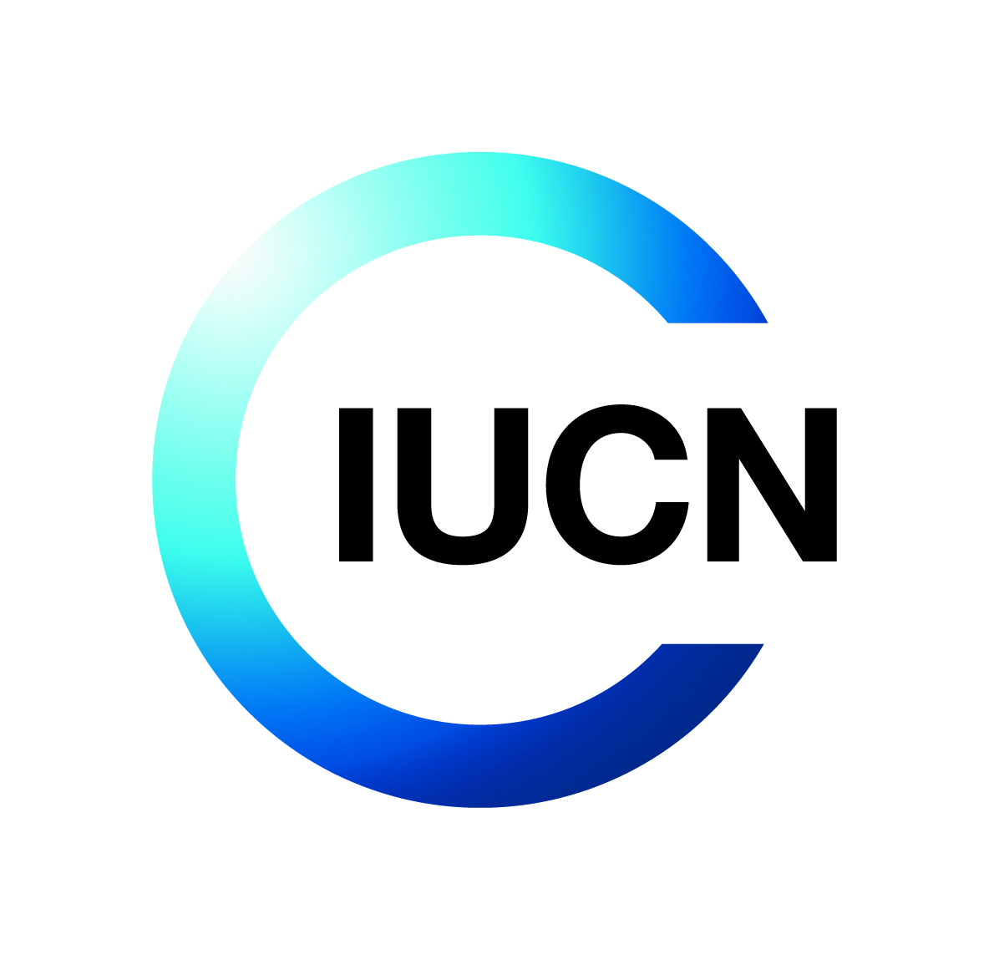Terms of Reference for IUCN Consultancy

**Title: Developing a Communication Package for AREECA Project**

**Objective of the Consultancy**

The main objective is to compile and design a compelling suite of communication products that highlight the results, innovations, and lessons learned from the AREECA project in Rwanda. This includes:

* Editing and designing reports
* Developing simplified communication materials (infographics, videos, brochures, etc.)
* Filming and photography (may include drone footages)
* Producing high-impact knowledge and visibility materials suitable for national and international dissemination

The final products will support policy influence, public engagement, donor communication, and scaling-up of restoration practices.

**Background**

Project Reference: **P02954**

Donor reference: **DN00292**

**About IUCN**

IUCN is a membership Union uniquely composed of both government and civil society organisations. It provides public, private and non-governmental organisations with the knowledge and tools that enable human progress, economic development and nature conservation to take place together.

Created in 1948, IUCN is now the world’s largest and most diverse environmental network, harnessing the knowledge, resources and reach of more than 1,400 Member organisations and around 15,000 experts. It is a leading provider of conservation data, assessments and analysis. Its broad membership enables IUCN to fill the role of incubator and trusted repository of best practices, tools and international standards.

IUCN provides a neutral space in which diverse stakeholders including governments, NGOs, scientists, businesses, local communities, indigenous peoples organisations and others can work together to forge and implement solutions to environmental challenges and achieve sustainable development.

Working with many partners and supporters, IUCN implements a large and diverse portfolio of conservation projects worldwide. Combining the latest science with the traditional knowledge of local communities, these projects work to reverse habitat loss, restore ecosystems and improve people’s well-being.

[www.iucn.org](http://www.iucn.org)

<https://twitter.com/IUCN/>

**About the Project**

The Alliance for Restoration of Ecosystems in Africa (AREECA) is a multi-country initiative funded by the Federal Ministry of the Environment, Nature Conservation, and Nuclear Safety (BMU) of Germany. Implemented by a consortium comprising IUCN, FAO, WRI, WWF, AUDA-NEPAD, and the World Bank, the project operates across Rwanda, Kenya, Malawi, and Cameroon. AREECA seeks to enhance the economic, ecological, and climate benefits of large-scale Forest Landscape Restoration (FLR) by restoring 100,000 hectares of degraded land through sustainable land use options, while also catalyzing restoration efforts beyond the initial landscapes and countries.

In Rwanda, AREECA is working to restore 25,000 ha of degraded lands by initiating viable land-use options on 5,000 ha in Kirehe and Nyagatare Districts and establishing various enablers to catalyse restoration—a move that is expected to have a fivefold radiative effect in East Province and beyond. Now in its 5th year of implementation, the project is also designed to enhance local FLR capacity among stakeholders, provide policy advice on FLR, unblock large-scale restoration, and share FLR experiences and lessons learned. Some of the long-term benefits that are expected from this project include the reduction of GHG emissions, improved community resilience (particularly of poor subsistence farmers, women, and pastoralists) to the negative impacts of climate change, and reduced pressure on biodiversity and habitats.

To this end, the project, which works very closely with TREPA[1] & COMBIO[2], has yielded tremendous results, showing incredible impacts on people and landscapes. For example, the project has already put 5,114 ha of land under restoration where about 38% of tree species are native. The project has benefited over 48,000 people, including women and youths and continues to impact several more farmers through the local bio-enterprise that have been empowered. AREECA has also supported a sub-national ROAM assessment and the development of a sub-national restoration strategy, informing restoration strategies in seven (7) districts in the Eastern province. The project has further developed various innovative approaches that are set to inform scaling-up efforts beyond AREECA.

Compiling and packaging such results, impacts, and successes (lessons learned and best practices) is not only critical for scaling up restoration but also for inspiring restoration actions in Rwanda and beyond. It’s within this context that IUCN-Rwanda is seeking to recruit a communication expert/firm to compile and package communication materials for the AREECA project in Rwanda.

**Description of the Assignment**

In close collaboration with IUCN Rwanda Country Office and Project partners, the consultant is expected to undertake the following tasks:

1. Proofread, edit (where necessary), and brand/design layouts for the following documents/existing reports:
2. AREECA baseline survey report
3. Urban and roadside forestry guideline report
4. Value chain report
5. Districts Forest Management Plan reports (2)
6. Rwanda Sub-national (Eastern province) ROAM report as well as the 7-Districts restoration Strategies reports.
7. Piloting Payment for Ecosystem Services (PES) through Public-Private- Partnership (PPP) concept for Eastern province.
8. The Community Centric Restoration Approach for Eastern Province
9. The Community Environment Conservation Scheme (CECS) feasibility study and a concept for Eastern province.
10. A simplified guide for implementation of DFMPs in Rwanda.
11. Produce a 10-page, infographic-rich summary of AREECA's impacts across biophysical, socio-economic, policy, and governance domains.
12. Develop five Panorama solutions (success stories - in the format required by Panorama platform).
13. Carry our videography of key AREECA landscape in Kirehe and Nyagatare and produce a max 15 min HD explainer video describing project biophysical and social economic impacts.
14. Prepare high-level policy and technical briefs on the following themes:
15. Urban and roadside forestry in Rwanda.
16. FLR for Livelihoods and Human Wellbeing – Focusing on High Impacts Value chains in Eastern Province, Rwanda.
17. Community Centric Restoration Approach for Eastern Province.
18. Evidence-based PES concept
19. FLR baselining and optimization using ROAM-based Geospatial Protocol.
20. FLR Cross-sectoral Coordination: A Powerful Restoration Success factor in Rwanda.
21. Community Environment Conservation Scheme (CECS) as an inclusive financing mechanism and for accelerated grassroot action.
22. The art of community mobilization for accelerating FLR – lessons learned in Rwanda trough AREECA.

**Duration of the Assignment**

20th June 20205 – 30th July 2025

**Deliverables and Activities**

The consultant will provide the following deliverables and carry out the following activities:

|  |  |  |
| --- | --- | --- |
| **Deliverable** | **Description** | Timeline |
| **1. Inception Report** | Including understanding of ToR, proposed tools/formats, and detailed work plan | 5 days |
| **2. Desk Review** | Synthesis of project documentation and published media. | 5 days |
| **3. Fieldwork** | Photography, interviews, filming, and data collection. | 10 days |
| **4. Draft Products** | Submission of initial drafts of all communication materials. | 25 days |
| **5. Final Package** | Submission of final, validated communication package incorporating feedback. | 5 days |

**Payment Schedule**

The timetable below summarises the chronological order of deliverables and indicates milestones at which IUCN will pay the Consultant.

|  |  |
| --- | --- |
| **Deliverable** | **Milestone payment** |
| 25 June 2025 – Upon Inception Report | **30%** |
| 04 July 2025 - Following the submission of the Draft Products | **30%** |
| 25 July 2025 – Upon Submission of final, validated communication package incorporating feedback. | **40%** |

**Skills and Experience**

The consultant must have the following skills, education and experience as a minimum:

* Advanced degree in the field of mass communications, journalism, digital media, or other relevant fields that fits this assignment.
* Minimum 7 years of professional experience in strategic communications for development or environmental projects in Rwanda. Having worked in Forest Landscape Restoration (FLR) or climate related project is an added advantage.
* Extensive experience in writing, editing, developing, designing, and producing, high quality communication products for NGOs or UN Agencies.
* Proven skills in proofreading high-level reports are highly recommended.
* Proven skills in videography/filming (including working with accredited drone filming experts and companies in Rwanda), photography, subtitling and voiceover is a must.
* Experience in conducting interviews, writing feature articles, and producing best lesson stories is strongly recommended.
* Fluency in English and Kinyarwanda (both written and spoken).
* Strong literary analysis skills, including capacity to synthesise project/research literature, desk review and producing high-level report briefs and articles.

**Supervision and coordination**

Under the guidance of IUCN team, the consultant will work closely with IUCN staff and implementing partners from Ministry of Environment, Rwanda Forestry Authority, GIZ, World Resources Institute and Rwanda Rural Rehabilitation Initiative, RWARRI. The consultant may also be required to carry out interviews with key members of the national Cross Sectoral Task Force and district level restoration committee members.

1. https://www.greenclimate.fund/project/fp167
2. https://www.rfa.rw/1/projects/combio