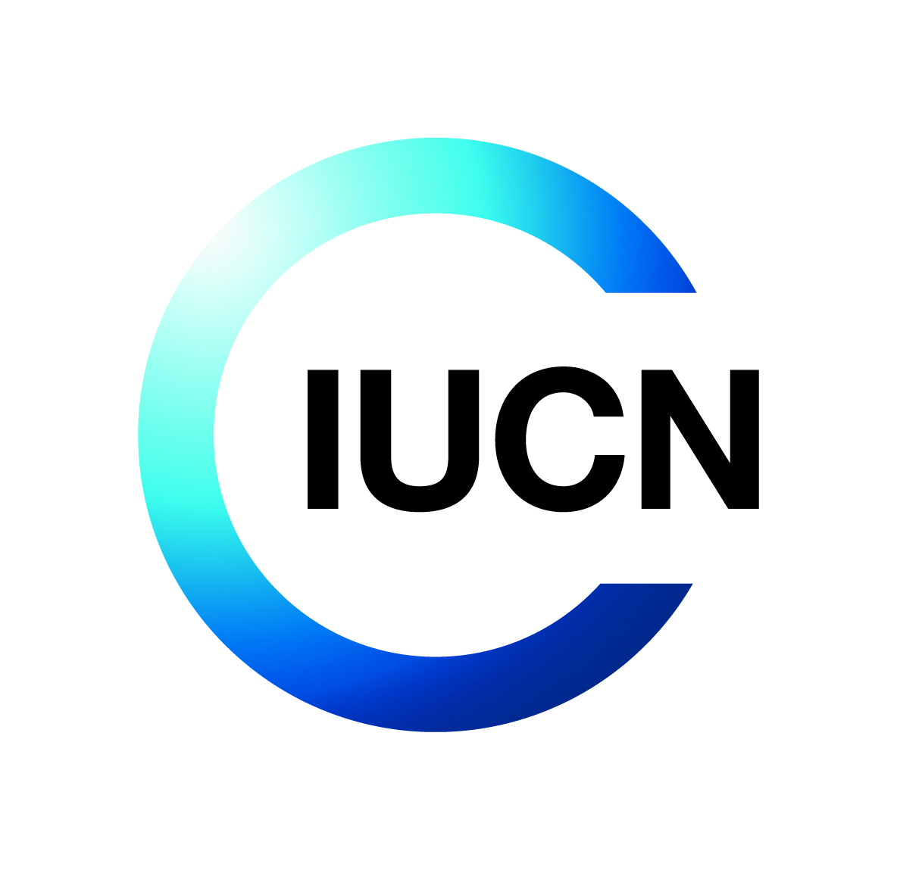

Terms of Reference for IUCN Consultancy

**Title:** Documentation of TREPA Achievements 2022-2025

1. **Objectives**

The consultancy services under these terms of reference pursue the following objective: gathering information and documentation of TREPA project achievements.

It is expected that the outcome from these consultancy services will:

* Provide one single illustrated and comprehensive report (maximum 40 pages) summarizing the achievements from TREPA’s interventions to date.
* Promote accountability for the results achieved through TREPA.
* Utilize available data and reports to assess and document the reach and impact of TREPA project implementation on farmers, landscapes put under restoration, farmer organizations (FFPs, cooperatives, SMEs, etc.), districts, and other government entities.
* Facilitate knowledge sharing among key stakeholders based on the experiences of implementing partners.

1. **Background**

Project Reference: P03168

Donor reference: FP167

1. **About IUCN**

IUCN is a membership Union uniquely composed of both government and civil society organisations. It provides public, private and non-governmental organisations with the knowledge and tools that enable human progress, economic development and nature conservation to take place together.

Created in 1948, IUCN is now the world’s largest and most diverse environmental network, harnessing the knowledge, resources and reach of more than 1,400 Member organisations and around 15,000 experts. It is a leading provider of conservation data, assessments and analysis. Its broad membership enables IUCN to fill the role of incubator and trusted repository of best practices, tools and international standards.

IUCN provides a neutral space in which diverse stakeholders including governments, NGOs, scientists, businesses, local communities, indigenous people’s organisations and others can work together to forge and implement solutions to environmental challenges and achieve sustainable development.

Working with many partners and supporters, IUCN implements a large and diverse portfolio of conservation projects worldwide. Combining the latest science with the traditional knowledge of local communities, these projects work to reverse habitat loss, restore ecosystems and improve people’s well-being.

[www.iucn.org](http://www.iucn.org)

<https://twitter.com/IUCN/>

1. **About the Project**

The current ESARO programming is composed of a suite of mutually interrelated programs and projects designed to address some of the most profound challenges affecting people and nature in the region. Among the projects implemented by IUCN’s Eastern and Southern Africa Regional Office is the TREPA Project – Transforming Eastern Province through Adaptation. It is a six-year project, based in IUCN Rwanda Country Office, and funded by the Green Climate Fund (GCF).

The TREPA Project intends to restore 60,000 hectares of drought-degraded landscapes into climate resilient ecosystems through re-forestation, agroforestry, restoration of pasturelands, and soil erosion control measures in the Eastern Province of Rwanda. In addition, irrigation infrastructure projects in the targeted landscapes of the eastern province will be climate-proofed by the TREPA Project.

The TREPA Project will finally support the national and local institutions to effectively plan, manage and monitor climate adaptation outcomes from improved land use at national and decentralized levels.

The TREPA Project is implemented by IUCN (accredited entity) together with the Rwanda Forestry Authority and Enabel as executing entities in partnership with ICRAF, World Vision, and CORDAID. The Ministry of Environment is responsible for chairing the Project Steering Committee and ensures coherence with national strategies and policies.

TREPA is designed to strengthen climate resilience of forest landscapes, people and markets, and subnational institutions. By employing a paradigm shift approach to deployment of nature-based solutions, TREPA hypothesizes that adoption of these NbS within 100 landscapes (each landscape comprising of 400 ha of agroforestry adjacent to protected forest, public forest, smallholder private forest and pasturelands) will positively impact livelihoods and resilience of smallholder farmers and the health of their lands while creating environmental co-benefits.

For its implementation, three components are considered:

Component 1: Restored landscapes that support climate resilient agro-ecological systems and livelihoods in Eastern Province.

Component 2: Market and value chain development for climate resilient agricultural and tree products linked to financial products and services for sustainable management of agro-ecological systems.

Component 3: Strengthened enabling environment to effectively plan, manage and monitor climate adaptation outcomes from improved land use at national and decentralized levels.

1. **Description of the Assignment**

This assignment will use primary and secondary data from implementing partners and reports to collect, summarize and organize the key achievements (outputs & outcomes) from different implementing partners.

The documentation of TREPA achievements will concern all its implementing partners’ interventions, project documents, reports, project monitoring data, government data, etc.). The consultant will quantify and describe the achievements with data relevant key performance indicators, present a comparison of the situation before and the state with the project; all presented visually using charts, graphs, and images, that demonstrate achievements that communicate key information effectively to readers.

The consultant will clearly elaborate on the approach and methodology he/she will use to accomplish the following tasks:

1. **Review and analysis of project documents, reports and data**

The consultant will work closely with the M&E, Communications team and project managers from different implementing partners (IPs). The documents below will be availed to the consultant:

* The project appraisal document
* Annual Work Plan and Budget (2022-2025)
* Annual Performance Reports (2022 -2024)
* TREPA Project Baseline Report
* TREPA Annual Household Survey Report
* TREPA Proposal and relevant reports
* Gender and Youth Action Plan
* Environmental and Social Management Framework
* Publications and events

The consultant will hence be able to understand the project background, key stakeholders and how each of them is contributing to the success of the project. He/she will identify the main achievements (quantity &quality), existence/or lack of synergy between different interventions and lessons learned that should be highlighted in the report.

Based on expected deliverables for each implementing partner, the consultant will gather and compile all relevant deliverables declared achieved from the IPs. Arranging this documentation in a single structured folder per output/Activity/deliverables will facilitate not only easy reference for any user but also constitute a proof and supporting document of each accomplishment.

1. **Collection of additional qualitative data**

This is expected to be collected using key informant interviews with IP’s key staff including hub coordinators and selected chairpersons of the district project coordination committees (DPCC) to compliment the analysis of project documents and shape the outcomes with in-depth understanding of the dynamics of project impact. Key Informant Interviews (KIIs) are envisaged for complementing the information from desk reviews and data gathered from project reports.

1. **Ensure full participation**

The consultant will keep in mind the following:

* A stakeholders’ workshop will be organized to give them the opportunity to make their appreciation of the report. The Consultant will be responsible for communication with stakeholders in close collaboration with IUCN TREPA project Manager.
* The project will need to communicate achievements and lessons learned among the consortium partners and avail it to external consultants for reference in subsequent project evaluations and thematic studies. In close collaboration with MEL staff, Project indicators will be updated via review of project reports and other records. This will be among other annexes to the main report.

1. **Duration of the Assignment**

It is planned that the assignment will commence immediately after signing the contract and last for 20 working days. The Consultant is responsible for submitting a detailed timetable for the various activities to be undertaken. This should include, but not limited to, the following outputs in the timescale indicated below:

|  |  |  |
| --- | --- | --- |
| **Activity** | **Est. # Days** | **Responsible** |
| Discussions about the objectives and the outcomes of the study with ITREPA team | 1 | Consultant & TREPA Team |
| Review of documents, identification of pertinent questions, information or data and draw the draft report content structure | 2-3 | Consultant |
| Submission of the Inception Report | 4 | Consultant |
| Presentation of the Inception Report | 7 | Consultant & TREPA team |
| Documents/knowledge products analysis and report writing linking outputs to outcomes | 8-12 | Consultant |
| Submission of the first draft report & draft documentary for review | 12 | Consultant |
| Draft report and analysis and feedback  by the project | 13-14 | TREPA Team |
| Incorporate observations and comments and submit second draft to the project | 15 | Consultant |
| Submit the draft final report | 16 | Consultant |
| Validation workshop | 16-18 | Consultant & TREPA Team |
| Include observations and comments from participants | 19 | Consultant |
| Submit the final report | 20 | Consultant |

1. **Deliverables and Activities**

The consultancy service will run from **5th May to 30th May 2025**. The expected deliverables are:

|  |  |  |
| --- | --- | --- |
| **Deliverable/Activity** | **Description** | **Deadline** |
| **Inception report** | Produce an **Inception Report** within 7 days from contract signature date including methodology, data collection tools, detailed work plan, analysis plan, proposed outline of the report and timeframe for IUCN inputs and decisions. He/she will convene an inception meeting/workshop to discuss the inception report with a view to making comments for improvement. This part should also elaborate on the production of the documentary film as well. | 10 June 2025 |
| **Draft report** | **A draft report** including a **3-pager high-level narrative and infographics** summarizing the project achievements and intermediate impact for review and comments. | 17June 2025 |
| **Validation workshop** | **Design and lead a validation workshop,** including presentation of preliminary findings. The validation workshop allows the consortium members to discuss the status and quality of the report and the visual part of it, providing inputs to the consultant. | 23 June 2025 |
| **Final Report** | Incorporate the comments and submit the **final report and a final 3-pager high-level narrative and infographics** summarizing the project achievements and outcomes. | 30 June 2025 |

1. **Cost**

Applicants are expected to submit a broken-down budget when submitting a proposal to IUCN. The budget is inclusive of professional/consultant fees, data collection and analysis, travel, and accommodation, reporting and validation costs.

1. **Payment Schedule**

The Timetable below summarises the chronological order of deliverables and indicates milestones at which IUCN will pay the Consultant.

|  |  |
| --- | --- |
| **Deliverable** | **Milestone payment** |
| Approved inception report | 20% |
| Validated Draft report | 30% |
| Approved Final Report | 50% |

1. **Supervision and coordination**

The consultant will report to and work under the supervision of the IUCN TREPA project Manager

1. **Skills and Experience**

The consultant (individual/consultancy firm) should satisfy the following minimum qualifications and requirements:

Consultant

* have an advanced degree (master’s or higher) in Environmental Sciences, Forestry, Agriculture, Agricultural Economics, Natural Resource, Food Systems and Nutrition, development studies or any other related fields
* have proven experience of a minimum of 5 years in carrying out studies in agriculture development, integrated agricultural systems, rural poverty alleviation and gender studies.
* At least five (5) years’ experience in socio-economic and food security assessment, and livelihoods assessment.

## Fluent in spoken and written English; Knowledge of Kinyarwanda language is added advantage

## Have a strong background and experience in a wide range of development, rural, socio-economic data analysis (proven by certificates of good completion).

## Have a strong experience in documenting project actions and achievements including infographic presentations of outcomes.

## 